Jason Palmeri

CSD200

Capstone Project

Bakery-Plus

Goals of the Website

Bakery-Plus is looking to expand their small local bakery by establishing a web presence. Bakery-Plus wants to have a website that allows its customers to order bakery goods in advance for pickup, and also to allow them to order from them and have it shipped to their house. They want to have a variety of shipping options available to their customers, including same-day and next-day delivery. Bakery-Plus wants to have an easy to navigate site that allows customers to search for baked goods they want to purchase, and add them to a shopping cart. Bakery-Plus will have a different selection of baked goods available on different days, so they will want to have an inventory management system to display what is in stock for that day. Once the customer has all their items in their cart, Bakery-Plus wants a detailed checkout page that includes the customers total cost, delivery options and their price. Bakery-Plus wants to have a user management system that will allow users to create accounts, login, and save their information for future purchases. Bakery-Plus would also like a rewards system for recurring customers.

Core Users of the Website

There are a variety of users that would use this website

1. Owner
   1. The owner would be able to track sales through the website, as well as see what items are more popular to increase sales.
2. Store Associate
   1. The store associate, while working at the location can also pick and pack the baked goods orders by looking at what has sold
3. Customer
   1. The website would allow customers to order baked goods, and sign up for rewards. The website would make it easier for customers who buy often from Bakery-Plus

Top 5 User Types 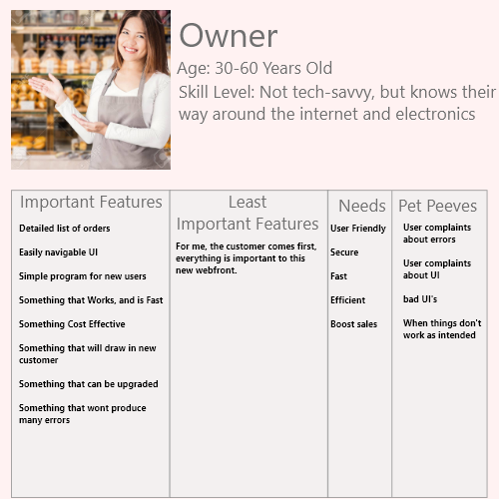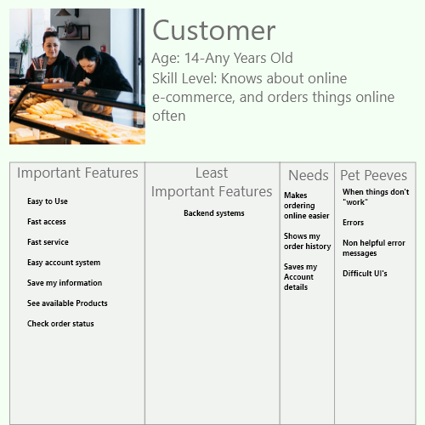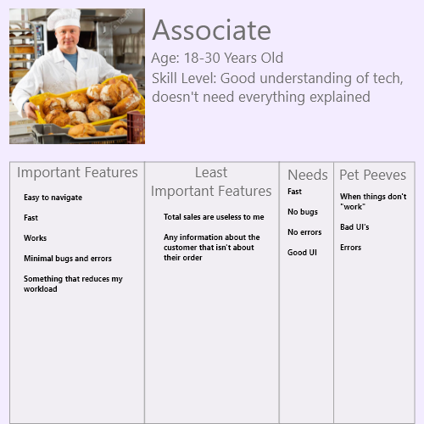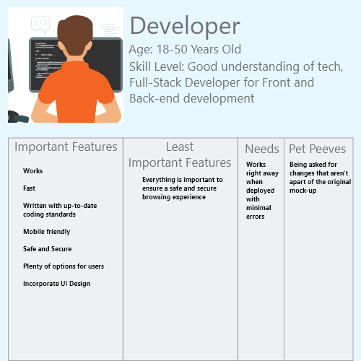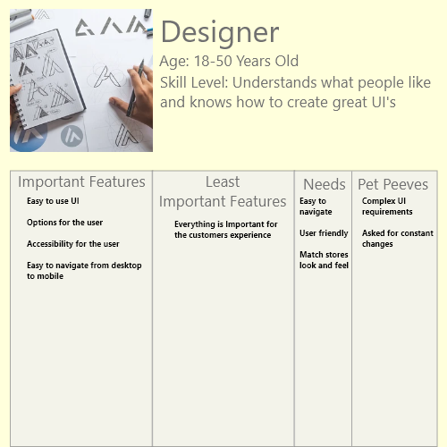

Executive Summary

Bakery-Plus has been the leading provider of baked goods in the New England area for over 15 years, providing friends and families from all around the state with exquisite baked goods, ranging from bread, to desserts. With the recent growth of Bakery-Plus It is important to grow your consumer base even more, by allowing users to access your services from anywhere, anytime.

In today's world everything is done digitally, we buy our toys online, our electronics, and more recently services like Doordash and Grubhub have been allowing us to order food, and groceries. As these services evolve it is important to start offering these types of services, and by hosting these services yourself, you eliminate the cost in fees that other companies charge to use their services. To do this Bakery-Plus will need to enter the Web industry and offer a website for your organization.

For Bakery-Plus I propose a custom built website, using a Shopify back-end. With this custom built solution, your customers would be able to access your store from anywhere on the web, from desktops to mobile devices. This web solution would allow your customers to create accounts to purchase your baked goods online, safely and securely. With this solution you would no longer be limited to doing business at your shop, but allow for customers to order in advance, and order items to be shipped to their homes. This solution could solve lines at your store, and reduce wait times that some customers may face. With this set of changes you can expect up to a 120% increase in sales by the end of 2023.

We here at JTP Consulting are experts when it comes to creating functional Shopify stores quickly, and efficiently. We are here to provide you with the tools and help to create your online business presence.

JTP Consulting loves to work with local companies like Bakery-Plus to provide them with tools to grow their business, and create more opportunities for their customers. Our company has helped many businesses locally renew and create their web presence such as Pets-R-Us, and Coating Systems Inc.

If you are ready to take the next step to increase your business to the online world, and boost sales, and customer satisfaction, then we here at JTP consulting are ready to take you there.

Jason Palmeri,

JTP Consulting

Written Proposal

Good Afternoon,

As discussed before for the plans to expand your business to the online world, we at JTP Consulting would be happy to guide you through the process of creating your new webfront. To begin we have the fees for the website domain, with a variety of options available. Unfortunately BakeryPlus.com is currently owned by another business, but we do have the following available: “BakeryPlus.store”, “TheBakeryPlus.com”. If neither of these are what you are looking for, JTP Consulting would gladly contact the owner of “BakeryPlus.com” and see if they would consider selling their domain. The price for “BakeryPlus.store” and “TheBakeryPlus.com” are around $20.00 per year.

As we mentioned in our RFP response, we would like to get you setup with a Shopify hosted website. Shopify is an online service that helps e-commerce websites get setup quick and easy, with tools to help you see how your business is doing. Shopify also simplifies the buying process for customers, with lightning fast checkouts. Shopify offers 3 plans, ranging from $29.00/month to $299.00/month. I believe for your growing business we should start you on the middle “Shopify” tier, for $79.00/month. You can view all the features available per plan here: <https://www.shopify.com/pricing>

Once these things are set up, we can have our design team here at JTP Consulting start drawing out your new website. We offer unlimited redesigns to our clients, to ensure that they get what they want. We expect this process to take one to two weeks, to ensure that the design is carefully crafted for the market, and your customers. Once the design is approved by you, we will get out developers to work to start creating your brand new website. The creation of your website should take no more than one months time, so that there is no downtime for your growing business.

After all of the systems are in place, and your website is uploaded, we offer 24 months of help and services to make sure there are no errors or bugs in the software that we provide.

For this service we have a flat fee of $15,000 for the creation of the web service, 24 months of support, and this price also includes 1 year of domain hosting, and Shopify services.

If you are ready to take the next step to increase your business to the online world, and boost sales, and customer satisfaction, then we here at JTP consulting are ready to take you there.

Jason Palmeri,

JTP Consulting

Top 5 Requirements (User/Owner)

1. As an **User** I Need **a good UI**, so that **I can quickly and efficiently use the website**
2. As an **User** I Need **a secure and safe website**, so that **I can buy and navigate the website without worrying about my personal information being exposed**
3. As an **User** I Need **detailed information about my purchases**, so that **I can track my orders, and see my bills**
4. As an **Owner** I Need **a secure and safe website**, so that **my customers feel safe when using my website**
5. As an **Owner** I Need **detailed admin page**, so that **I can check orders, and see how my store is doing online**
6. As an **Owner** I Need **an upgradable website**, so that **I can further expand my web presence**

Top 5 Requirements (UI/Dev)

1. As an **UI Designer** I Need **a Logo**, so that **I can create the design around it**
2. As an **UI Designer** I Need **to know the setting of the bakery, and the mood**, so that **I can design the website to match the vibe of the bakery**
3. As an **UI Designer** I Need **a list of features**, so that **I can design for each feature**
4. As an **Developer** I Need **the design document**, so that **I can create a prototype to show the designer, to make sure everything is right**
5. As an **Developer** I Need **to create a prototype for the owner to test**, so that **they can see if everything they need is available**
6. As an **Developer** I Need **to incorporate up-to-date development standards, and accessibility standards**, so that **every user can experience the website**

Wireframe

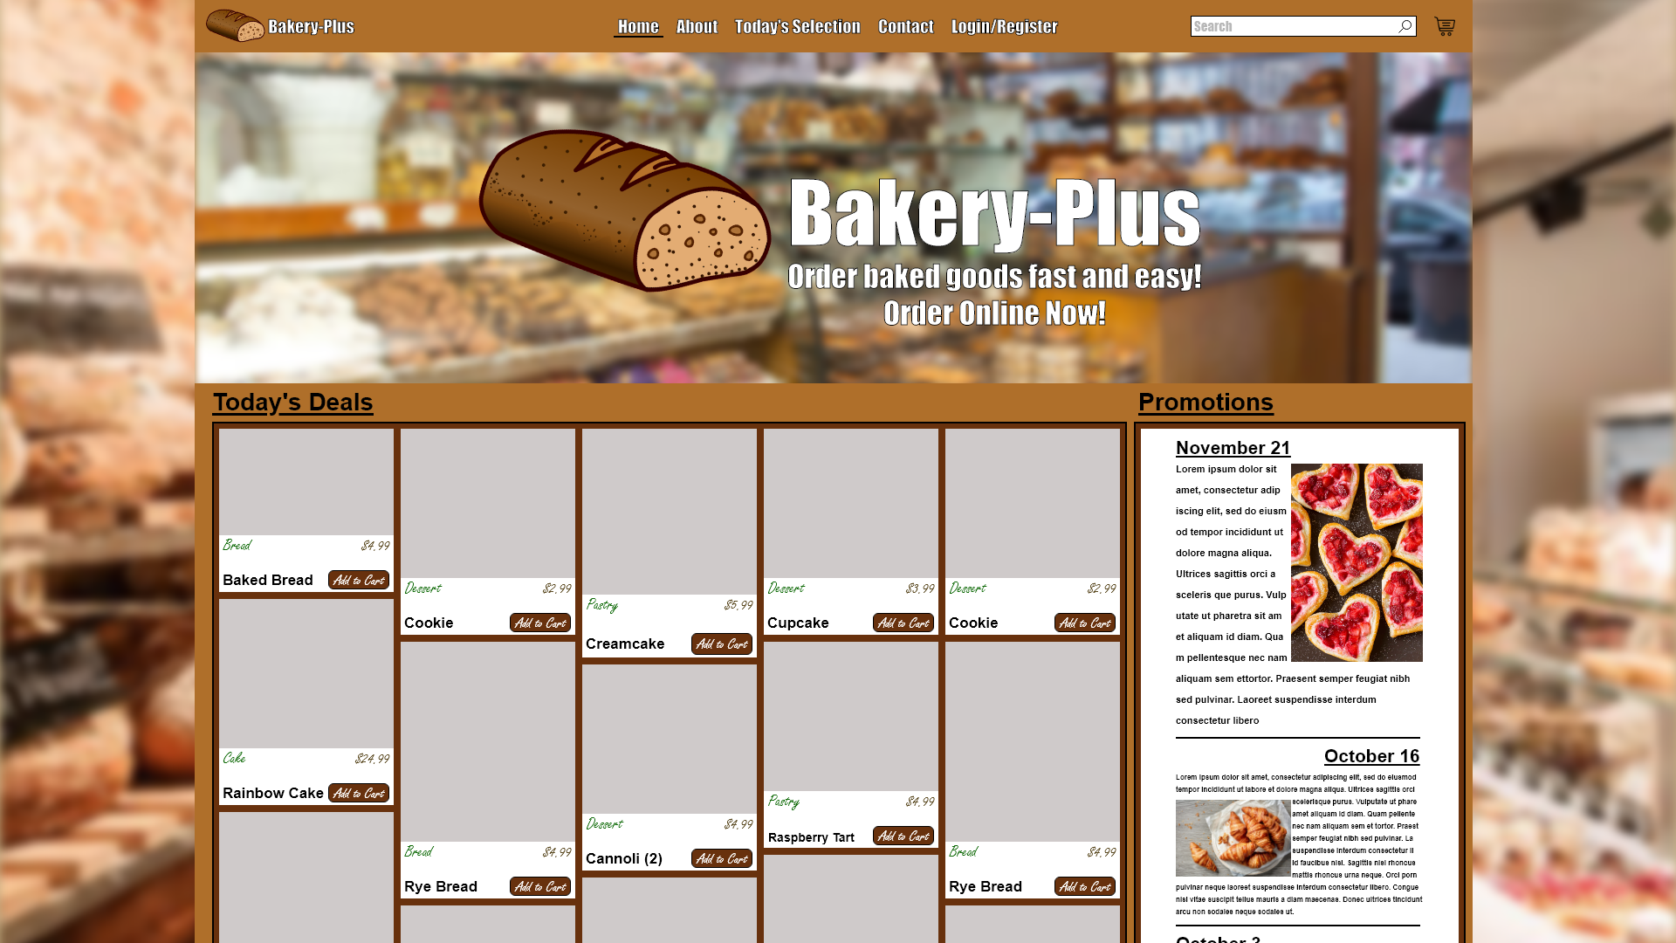

Accessibility and Standards

One of the most important things about ecommerce websites is to show the product, so for this homepage mock-up I added the grid of products, so that customers can see right away the types of things you offer. Each product is broken into a card container, type of product, product name, price, and each card features an Add to Cart button. On the right hand side I went for a promotions/news area so that new customers could see the type of things that returning customers get, and also to show if there are any sales. I went for a container-like setup where the page is centered with a background image for larger sized monitors. This would help later on for mobile scaling. For the navigation bar, I went with a simple brand logo/title on the left, with centered links on the top, and an underline on the current page. I did this to incorporate the search bar in the top right, and the cart icon that was asked for. If a user signs in I would put their user account area to the left of the cart. I went with a “bread” color palette to match the theme. For the main call to action banner I added an enlarged logo, with some text to show that you are now accepting online orders.

Assumptions

I assume “Bakery-Plus” has a logo

I assume “Bakery-Plus” has a style and color choice

Citation

Images for wireframe are from google images

<https://color.adobe.com/bread-color-theme-2369183/> color theme

Images for personas from google images